# Lab: Basic Syntax, Conditional Statements and Loops

## Multiply number by 2

Write a function that receives a number and prints as result that number multiplied by two

### Examples

|  |  |
| --- | --- |
| **Input** | **Output** |
| 2 | 4 |
| 5 | 10 |
| 20 | 40 |

### Hints

Create a function called solve (or some other name). As parameters it will receive a number. Print the number multiplied by 2

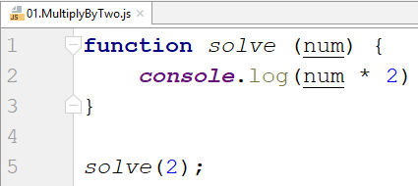

## Excellent grade

Write a function that receives a single number and checks if the grade is excellent or not. If it is, print "Excellent", otherwise print "Not excellent"

### Examples

|  |  |
| --- | --- |
| **Input** | **Output** |
| 5.50 | Excellent |
| 4.35 | Not excellent |

### Hints

Check if the number given is greater or equal to 5.50 and print the corresponding result

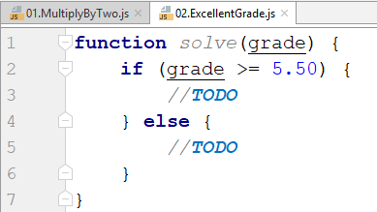

## Numbers from 1 to 5

Create a function that prints all the numbers from 1 to 5 (inclusive) each on a separate line

### Hints

Create a for loop starting from 1 and continuing until 5 and print the number

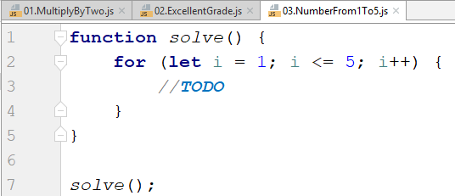

## Numbers from N to 1

Create a function that receives a number N and prints all the numbers from N to 1. Try using while loop

### Examples

|  |  |
| --- | --- |
| **Input** | **Output** |
| 5 | 5  4  3  2  1 |
| 3 | 3  2  1 |

### Hints

Create a while loop with condition N >= 1. Print N and decrease it with each step

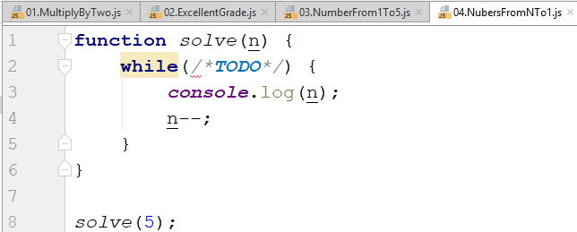

## Numbers from M to N

Write a function that receives a number M and a number N (M will always be bigger than N). Print all numbers from M to N

### Examples

|  |  |
| --- | --- |
| **Input** | **Output** |
| 6  2 | 6  4  3  2 |
| 4  1 | 4  3  2  1 |

### Hints

Use for or while loop and print the numbers

